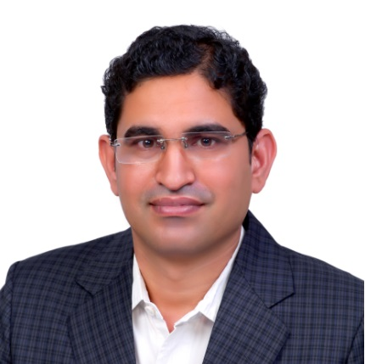
Mahesh KUMAR
Dr. Mahesh Kumar is Assistant Professor at Department of Electrical Engineering, Indian Institute of Technology Jodhpur, Jodhpur, Rajasthan, India.
He has received M.Sc degree in Physics from University of Rajasthan in 2003 and M.Tech degree in Solid State Materials from Indian Institute of Technology Delhi in 2005. He has received Ph.D degree from Indian Institute of Science (IISc) Bangalore in 2012.
Kumar has worked at Central Research Laboratory of Bharat Electronics Ltd. Bangalore (CRL-BEL) as Scientist from 2005 to 2013. He worked on industry-academia collaboration that involved CRL-BEL and Materials Research Centre, IISc Bangalore. He was involved in the development of GaN based blue LEDs, Quantum-well infrared photodetectors, Solar cells and III-V quantum dots based detectors. He also worked at University of Paderborn, Germany, as visiting scientist under Bilateral Exchange Programme of the Indian National Science Academy (INSA). He was awarded INSA Medal for Young Scientists-2014 and the MRSI Medal (2016) by Materials Research Society of India. He is founding Member of Indian National Young Academy of Sciences (2015-2019).
Since 2013 Mahesh Kumar is an Assistant Professor at Department of Electrical Engineering in Indian Institute of Technology (IIT) Jodhpur. His scientific interests are focused on III-Nitride semiconductors, Oxide metal semiconductors for sensor applications and Bandgap engineering and surface studies of semiconductors. He authored more than 50 papers published in peer-reviewed journals (Applied Physics Letters, Journal of Applied Physics, Materials Research Bulletin, Surface Science, Thin Solid Films, etc.).
h-index = 10

